COP 2251 – Java Programming II – Lists, Stacks, Queues - Chapter 20

* Collections are objects that hold and organize other objects, usually of the same type.
* The objects in a collection are called the elements of the collection.
* A collection cannot have primitive data types as elements, only reference types (objects).
* Wrapper classes like Integer and Double are used to store numbers in a collection.
* The **java.util** package contains the “Collections Framework” (**CF**) to manage collections.
* In Java 1.5, the interfaces and classes of the Collections Framework were updated for generic data types.
* The Java CF consists of:
  + Interfaces that can be implemented to create collections.
  + Implementations (concrete classes) of these interfaces.
  + Static Methods that perform common tasks on collections.
* There are 3 main kinds of collections:

1. **Sets**: collections of elements with no duplicates.
2. **Lists**: ordered collections of elements with duplicates possible.
3. **Maps**: collections of elements, each element having a key.

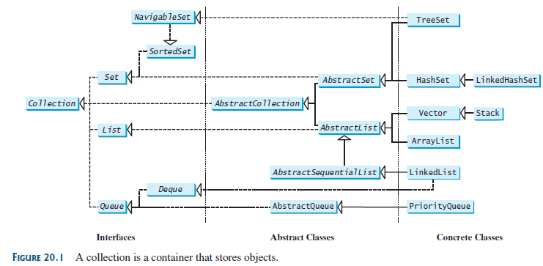

**The Collection Interface**

* As Figure 20.1 shows, this interface is the superclass of the CF.
* It contains core methods common to all collections.
* Study the Collection methods in the UML diagram in Figure 20.2 on page 778.
* NOTE: Rather than implementing the Collection interface, coders usually choose the best concrete class from the Java CF for the new application.

Try **TestCollection.java**.

**The Iterator Interface**

* This interface is used to pass through (iterate over) the elements of a collection.
* The Iterator interface has three methods. See again UML in Figure 20.2.
* Think of an iterator as a “pointer” between collection elements.
* The **hasNext()** method will return true if the collection contains another element.
* The imaginary pointer “hops over” elements with **next()** method calls.
* The **remove()** method will remove the last element returned by the iterator.

Run **TestIterator.java**.

* Note the **iterator()** method that returns an instance of interface **Iterator**.

**The forEach Method**

* This (new in Java 8) method makes it easy to process every element in a collection.
* Code it with a lambda as shown in Liang’s next example.

Run **TestForEach.java**

**The List Interface**

* A list is an ordered collection in which each element has an index (starting from 0).
* Duplicate elements and null values are allowed. All elements are of the same data type.
* The List interface extends Collection and includes its methods.
* List also defines its own methods. See the UML diagram in Figure 20.3 on page 783.

**The ListIterator Interface**

* The Iterator interface also has a **ListIterator** sub-interface for iterating forward or backward through a **list** type of collection.
* ListIterator adds **previous( )** and **hasPrevious( )** for traversing in either direction.
* See the methods of ListIterator in the UML diagram in Figure 20.4 on page 783.
* As an interface, List cannot be instantiated but it has concrete classes.
* Two commonly used concrete classes are ArrayList and LinkedList.

**ArrayList**

* This is a resizable array implementation (arrays cannot be resized) of the List interface.
* JDK 1.5 revised ArrayList to include generics. See Figure 20.5.
* ArrayList is very similar to **Vector** but Vector is thread-safe. ArrayList is not.
* It also does not allow capacity increments as Vectors do.
* An ArrayList is best when you need to access any element at any index.
* ArrayList’s get(i) method is not efficient for traversing an entire list. Use an iterator.
* A foreach loop is efficient because it uses an implicit iterator. See boxes on page 786.

Try **ArrayListOne.java** (not in the book). Note the usage of ListIterator and forEach.

LinkedList



* A linked list is an ordered collection created with the **LinkedList** class.
* A linked list can grow or shrink in size.
* Like an ArrayList, LinkedList allows insertions in the middle of the list.
* Duplicates are allowed as with all lists.
* Use the methods of List to work with a linked list. See UML in Figure 20.6 on page 785.
* There are also doubly-linked lists as shown here.
* Linked lists can create other data structures like stacks, queues, trees, and dequeues.
* Use LinkedList when you need to add/delete elements to the beginning of a list.
* ArrayList is more efficient for retrieving elements.
* An iterator is more efficient for traversing a LinkedList than a loop with the get() method.
* Iterator doesn’t have an add() method, but ListIterator does.
* This add( ) method will add a new element before the iterator’s current position.

Try **LinkListOne.java** and **TestArrayAndLinkedList.java**.

**The Comparator Interface**

* The **Comparable** interface (Section 13.6) has a **compareTo()** method for comparing objects of the same class.
* The **Comparator** interface can compare objects that don’t implement Comparable or objects of two different classes.
* Comparator has the **compare()** method for this. See page 787.

Examine **GeometricObjectComparator.java.**

Then try **TestComparator.java**.

Try **SortStringByLength.java**

* It uses inner class MyComparator to compare String lengths

Try **SortStringIgnoreCase.java**

* This example does an alphabetical, case-insensitive sort of Strings with a nifty lambda.
* Note also that a method reference can be used.
* Interface Comparator has a static comparing() method that can execute a lambda expression or a method reference, as an alternative to making an inner class. See page 790. Then, try **SortStringByLength2.java** (not in book).
* The comparing method can also be used to make a Comparator that compares object properties. See again page 790.
* Class Comparator also has a thenComparing() method for secondary, or deeper, sorts. See page 790.
* Chaining the reverse() method to comparing() can reverse a sort. See page 790.

Examine class **Human.java** and then try **HumanSortByNameAndAge.java**

Static Methods for Lists and Collections

* Class **Collections** contains a large number of static methods for manipulating lists.
* See Figure 20.7 on page 791 for a UML diagram of these methods.
* Examine the numerous examples using these methods on pages 792-794.

Case Study: Bouncing Balls

Try **MultipleBounceBall.java**. It would be a good screen saver.

**Class Vector**

* This legacy class was updated for generics. It’s like an ArrayList except that its methods are synchronized to be thread-safe.
* If synchronization is unnecessary, ArrayList is more efficient.
* See UML for Vector in Figure 20.10 on page 798.
* Use Vectors when you need to avoid the corruption danger caused by multiple threads.
* Vectors can expand by a capacity that can be specified in the constructor.
* The line below creates a vector with an initial capacity of 100 Double elements that will expand by 10 elements when more capacity is required:

**Vector<Double> v1 = new Vector<Double>(100,10);**

Try **VectorOne.java**. This “extra” is not in the book.

**Class Stack**

* The Stack class is a last-in first-out (**LIFO**) stack of objects. It extends class Vector.
* When a stack is first created, it contains no objects.
* See the UML diagram in Figure 20.11 for the methods of the Stack class.

**peek()** looks at the top element of the stack without removing it.

**pop()** removes and returns the top element.

**push()** adds an element to the top of the stack.

Try **BookStack.java**. This “extra” is not in the book.

**The Queue and Deque Interfaces**

* A queue (4 consecutive vowels!!) is a first-in first-out (**FIFO**) collection.
* You have suffered in a queue at fast food eateries, banks, telephone support, etc.
* See Figure 20.12 on page 800 for the methods of Queue.
* As shown in Figure 20.13, class **LinkedList** is a concrete implementation of the Queue interface, so you can use it create queues in your programs.
* A **deque** (or dequeue) is a double-ended queue, enabling inserts and deletes at both ends.
* The interface **Deque** is a sub-interface of Queue. See Figure 20.13.

Try **TestQueue.java**.

**Class PriorityQueue**

* This concrete class inherits from the Queue interface. See Figure 20.14.
* PriorityQueue uses natural ordering (alpha for strings) to sort its elements.

Try **PriorityQueueDemo.java**.

* First loop sorts in natural order (alpha) and second loop sorts in reverse alpha.

Case Study: Evaluating Expressions

* This interesting study uses two Stack instances to evaluate expressions.

Try **EvaluateExpression.java**. Use command line arguments in Eclipse to run it.